**Interactividad: Actividad de autoaprendizaje Nº1: sopa de letras**

Por favor diseñar un esquema interactivo como el que se muestra a continuación, sobre la actividad de autoaprendizaje Nº1.

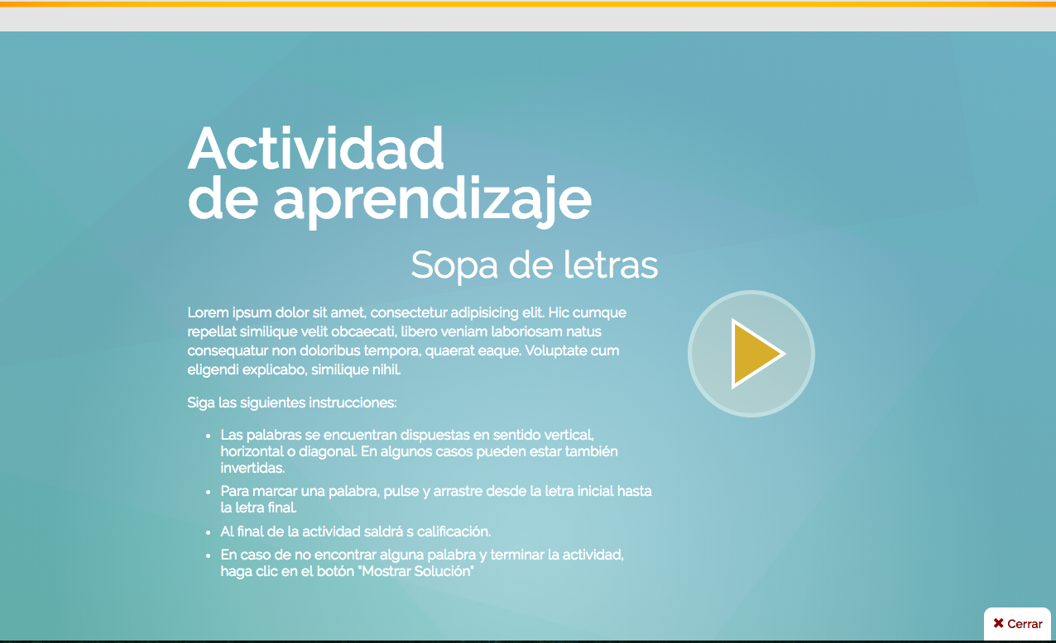

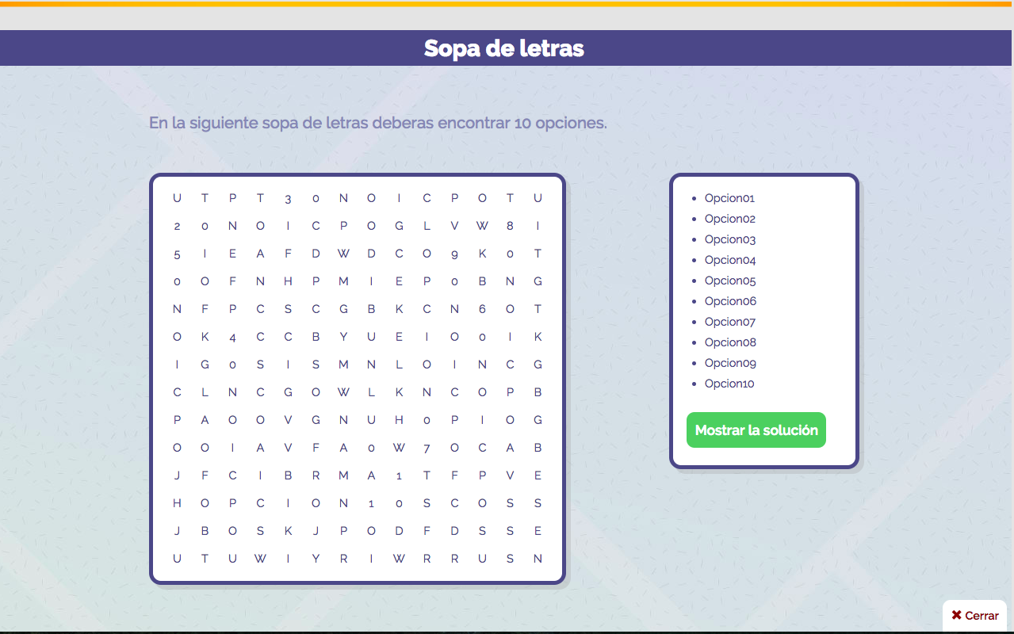

Título: Actividad de autoaprendizaje Nº1: sopa de letras

Instrucción al estudiante: Encuentra en la sopa de letras las siguientes palabras:

*SOFTWARE*

CUATRO PL

TRES PL

UML

RFID

XML

WMS

EDI

ESTRATEGIAS COLABORATIVAS

|  |  |  |  |  |  |  |  |  |  |  |  |  |  |  |  |  |  |  |  |  |  |  |  |  |  |  |  |  |  |  |  |  |  |  |  |  |  |  |  |  |  |  |  |  |  |  |  |  |  |  |  |  |  |  |  |  |  |  |  |  |  |  |  |  |  |  |  |  |  |  |  |  |  |  |  |  |  |  |  |  |  |  |  |  |  |  |  |  |  |  |  |  |  |  |  |  |  |  |  |  |  |  |  |  |  |  |  |  |  |  |  |  |  |  |  |  |  |  |  |  |  |  |  |  |  |  |  |  |  |  |  |  |  |  |  |  |  |  |  |  |  |  |  |  |  |  |  |  |  |  |  |  |  |  |  |  |  |  |  |  |  |  |  |  |  |  |  |  |  |  |  |  |  |  |  |  |  |  |  |  |  |  |  |  |  |  |  |  |  |  |  |  |  |  |  |  |  |  |  |  |  |  |  |  |  |  |  |  |  |  |  |  |  |  |  |  |  |  |  |  |  |  |  |  |  |  |  |  |  |  |  |  |  |  |  |  |  |  |  |  |  |  |  |  |  |  |  |  |  |  |  |  |  |  |  |  |  |  |  |  |  |  |  |  |  |  |  |  |  |  |  |  |  |  |  |  |  |  |  |  |  |  |  |  |  |  |  |  |  |  |  |  |  |  |  |  |  |  |  |  |  |  |  |  |  |  |  |  |  |  |  |  |  |  |  |  |  |  |  |  |  |  |  |  |  |  |  |  |  |  |  |  |  |  |  |  |  |  |  |  |  |  |  |  |  |  |  |  |  |  |  |  |  |  |  |  |  |  |  |  |  |  |  |  |  |  |  |  |  |  |  |  |  |  |  |  |  |  |  |  |  |  |  |  |  |  |  |  |  |  |  |  |  |  |  |  |  |  |  |  |  |  |  |  |  |  |  |  |  |  |  |  |  |  |  |  |  |  |  |  |  |  |  |  |  |  |  |  |  |  |  |  |  |  |  |  |  |  |  |  |  |  |  |  |  |  |  |  |  |  |  |  |  |  |  |  |  |  |  |  |  |  |  |  |  |  |  |  |  |  |  |  |  |  |  |  |  |  |  |  |  |  |  |  |  |  |  |  |  |  |  |  |  |  |  |  |  |  |  |  |  |
| --- | --- | --- | --- | --- | --- | --- | --- | --- | --- | --- | --- | --- | --- | --- | --- | --- | --- | --- | --- | --- | --- | --- | --- | --- | --- | --- | --- | --- | --- | --- | --- | --- | --- | --- | --- | --- | --- | --- | --- | --- | --- | --- | --- | --- | --- | --- | --- | --- | --- | --- | --- | --- | --- | --- | --- | --- | --- | --- | --- | --- | --- | --- | --- | --- | --- | --- | --- | --- | --- | --- | --- | --- | --- | --- | --- | --- | --- | --- | --- | --- | --- | --- | --- | --- | --- | --- | --- | --- | --- | --- | --- | --- | --- | --- | --- | --- | --- | --- | --- | --- | --- | --- | --- | --- | --- | --- | --- | --- | --- | --- | --- | --- | --- | --- | --- | --- | --- | --- | --- | --- | --- | --- | --- | --- | --- | --- | --- | --- | --- | --- | --- | --- | --- | --- | --- | --- | --- | --- | --- | --- | --- | --- | --- | --- | --- | --- | --- | --- | --- | --- | --- | --- | --- | --- | --- | --- | --- | --- | --- | --- | --- | --- | --- | --- | --- | --- | --- | --- | --- | --- | --- | --- | --- | --- | --- | --- | --- | --- | --- | --- | --- | --- | --- | --- | --- | --- | --- | --- | --- | --- | --- | --- | --- | --- | --- | --- | --- | --- | --- | --- | --- | --- | --- | --- | --- | --- | --- | --- | --- | --- | --- | --- | --- | --- | --- | --- | --- | --- | --- | --- | --- | --- | --- | --- | --- | --- | --- | --- | --- | --- | --- | --- | --- | --- | --- | --- | --- | --- | --- | --- | --- | --- | --- | --- | --- | --- | --- | --- | --- | --- | --- | --- | --- | --- | --- | --- | --- | --- | --- | --- | --- | --- | --- | --- | --- | --- | --- | --- | --- | --- | --- | --- | --- | --- | --- | --- | --- | --- | --- | --- | --- | --- | --- | --- | --- | --- | --- | --- | --- | --- | --- | --- | --- | --- | --- | --- | --- | --- | --- | --- | --- | --- | --- | --- | --- | --- | --- | --- | --- | --- | --- | --- | --- | --- | --- | --- | --- | --- | --- | --- | --- | --- | --- | --- | --- | --- | --- | --- | --- | --- | --- | --- | --- | --- | --- | --- | --- | --- | --- | --- | --- | --- | --- | --- | --- | --- | --- | --- | --- | --- | --- | --- | --- | --- | --- | --- | --- | --- | --- | --- | --- | --- | --- | --- | --- | --- | --- | --- | --- | --- | --- | --- | --- | --- | --- | --- | --- | --- | --- | --- | --- | --- | --- | --- | --- | --- | --- | --- | --- | --- | --- | --- | --- | --- | --- | --- | --- | --- | --- | --- | --- | --- | --- | --- | --- | --- | --- | --- | --- | --- | --- | --- | --- | --- | --- | --- | --- | --- | --- | --- | --- | --- | --- | --- | --- | --- | --- | --- | --- | --- | --- | --- | --- | --- | --- | --- | --- | --- | --- | --- | --- | --- | --- | --- | --- | --- | --- | --- | --- | --- | --- | --- | --- | --- | --- | --- | --- | --- | --- | --- | --- | --- | --- | --- | --- | --- | --- | --- | --- | --- | --- | --- | --- | --- | --- | --- | --- | --- | --- | --- | --- | --- | --- | --- | --- | --- | --- | --- | --- | --- | --- | --- | --- | --- | --- | --- | --- | --- | --- | --- | --- |
| Esquema de la sopa de letras: | |  |  |  |  |  |  |  |  |  |  |  |  |  |  |  |  |  |  |  |  | | --- | --- | --- | --- | --- | --- | --- | --- | --- | --- | --- | --- | --- | --- | --- | --- | --- | --- | --- | --- | | Q | E | Z | X | C | V | B | E | N | A | V | R | G | Q | W | E | R | T | Y | U | | W | B | D | W | E | R | T | S | Q | W | E | R | T | Y | U | I | O | P | L | Ñ | | E | V | M | I | I | U | Y | T | A | S | D | F | G | H | J | K | L | Ñ | X | Z | | R | Q | M | N | B | V | C | R | Z | X | C | V | B | N | M | Q | W | E | R | T | | T | H | W | Q | A | Z | X | A | Q | W | E | R | T | Y | U | I | O | P | A | A | | Y | X | R | F | I | D | Q | T | D | S | D | C | V | C | D | F | E | W | W | Q | | U | S | M | N | B | V | C | E | A | N | A | V | R | G | Q | W | E | R | T | Y | | I | Q | W | Q | A | Z | X | G | S | Q | W | E | R | T | Y | U | I | O | P | L | | W | M | S | I | O | P | L | I | D | A | S | D | F | G | H | J | K | L | Ñ | X | | A | O | A | I | O | P | L | A | E | Z | X | C | V | B | N | M | Q | W | E | R | | S | I | S | L | Q | W | E | S | R | Q | W | E | R | T | Y | U | I | O | P | A | | D | U | D | M | U | I | O | C | A | D | S | D | C | V | C | D | F | E | W | W | | F | Y | F | U | E | R | L | O | W | D | V | R | G | Q | W | E | R | T | Y | U | | G | T | G | E | T | Y | M | L | T | W | E | R | T | Y | U | I | O | P | L | Ñ | | H | R | H | Q | W | E | X | A | F | S | D | F | G | H | J | K | L | Ñ | X | Z | | J | E | J | H | R | H | D | B | O | X | C | V | B | N | M | Q | W | E | R | T | | K | W | K | Q | W | E | A | O | S | W | E | R | T | Y | U | I | O | P | A | A | | L | Q | L | E | H | L | W | R | D | C | D | C | V | C | D | F | E | W | W | Q | | Ñ | M | Ñ | Q | P | A | S | A | A | V | A | V | R | G | Q | W | E | R | T | Y | | Z | N | E | S | W | W | X | T | W | E | W | E | R | T | Y | U | I | O | P | L | | X | B | E | Q | S | S | W | I | S | D | S | D | F | G | H | J | K | L | Ñ | X | | C | R | V | A | X | X | S | V | X | C | X | C | V | B | N | M | Q | W | E | R | | T | V | F | S | W | W | W | A | W | E | W | E | R | T | Y | U | I | O | P | A | | Z | C | R | X | S | S | E | S | S | D | S | D | C | V | C | D | F | E | W | W | | X | C | U | A | T | R | O | P | L | E | R | T | Y | U | I | O | P | L | P | A | |
| Solución: | |  |  |  |  |  |  |  |  |  |  |  |  |  |  |  |  |  |  |  |  | | --- | --- | --- | --- | --- | --- | --- | --- | --- | --- | --- | --- | --- | --- | --- | --- | --- | --- | --- | --- | | Q | E | Z | X | C | V | B | E | N | A | V | R | G | Q | W | E | R | T | Y | U | | W | B | D | W | E | R | T | S | Q | W | E | R | T | Y | U | I | O | P | L | Ñ | | E | V | M | I | I | U | Y | T | A | S | D | F | G | H | J | K | L | Ñ | X | Z | | R | Q | M | N | B | V | C | R | Z | X | C | V | B | N | M | Q | W | E | R | T | | T | H | W | Q | A | Z | X | A | Q | W | E | R | T | Y | U | I | O | P | A | A | | Y | X | R | F | I | D | Q | T | D | S | D | C | V | C | D | F | E | W | W | Q | | U | S | M | N | B | V | C | E | A | N | A | V | R | G | Q | W | E | R | T | Y | | I | Q | W | Q | A | Z | X | G | S | Q | W | E | R | T | Y | U | I | O | P | L | | W | M | S | I | O | P | L | I | D | A | S | D | F | G | H | J | K | L | Ñ | X | | A | O | A | I | O | P | L | A | E | Z | X | C | V | B | N | M | Q | W | E | R | | S | I | S | L | Q | W | E | S | R | Q | W | E | R | T | Y | U | I | O | P | A | | D | U | D | M | U | I | O | C | A | D | S | D | C | V | C | D | F | E | W | W | | F | Y | F | U | E | R | L | O | W | D | V | R | G | Q | W | E | R | T | Y | U | | G | T | G | E | T | Y | M | L | T | W | E | R | T | Y | U | I | O | P | L | Ñ | | H | R | H | Q | W | E | X | A | F | S | D | F | G | H | J | K | L | Ñ | X | Z | | J | E | J | H | R | H | D | B | O | X | C | V | B | N | M | Q | W | E | R | T | | K | W | K | Q | W | E | A | O | S | W | E | R | T | Y | U | I | O | P | A | A | | L | Q | L | E | H | L | W | R | D | C | D | C | V | C | D | F | E | W | W | Q | | Ñ | M | Ñ | Q | P | A | S | A | A | V | A | V | R | G | Q | W | E | R | T | Y | | Z | N | E | S | W | W | X | T | W | E | W | E | R | T | Y | U | I | O | P | L | | X | B | E | Q | S | S | W | I | S | D | S | D | F | G | H | J | K | L | Ñ | X | | C | R | V | A | X | X | S | V | X | C | X | C | V | B | N | M | Q | W | E | R | | T | V | F | S | W | W | W | A | W | E | W | E | R | T | Y | U | I | O | P | A | | Z | C | R | X | S | S | E | S | S | D | S | D | C | V | C | D | F | E | W | W | | X | C | U | A | T | R | O | P | L | E | R | T | Y | U | I | O | P | L | P | A | |